## ADDI

## Prerequisite for project with version

* Java 1.8
* STS
* Orient DB 3.0.15 or Any Latest Version
* Spring batch 2.1.1
* Spring-fox swagger UI 2.1.1
* Swaggerfox-swagger 2
* Apache Maven 3.6.0

(Note: All the dependency included in pom.xml, no need to add externally)

## Steps for project execution

1. Download ADDI

* Refer below link to download ADDI application
* <https://teams.microsoft.com/_#/files/General?threadId=19%3A8a192aa49613478085c2209cdacc41f3%40thread.skype&ctx=channel&context=ADDI%252F06-05-2019>
* Once click on the above link refer below path to download the ADDI project
* Path to download project from Microsoft teams: ADDIProject/files/ADDI/
* Download the project and create new folder inside local disk ‘C’ with name “**ADDI-WS**”

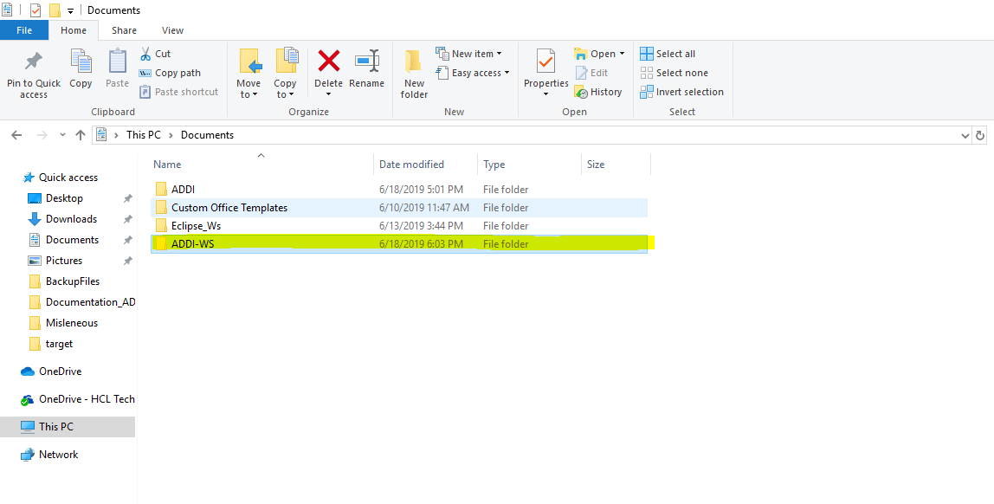

* Copy downloaded project in “ADDI-WS”

1. Importing ADDI

* To import ADDI application in STS environment follow the below steps
* Download the STS <https://spring.io/tools3/sts/all> with link for windows(download STS with latest version or 3.9.7 ) as same as your java version.
* Note: I am using java 32bit version and STS 32bit version
* Extract the downloaded STS and open it
* Click on ‘file🡪import’

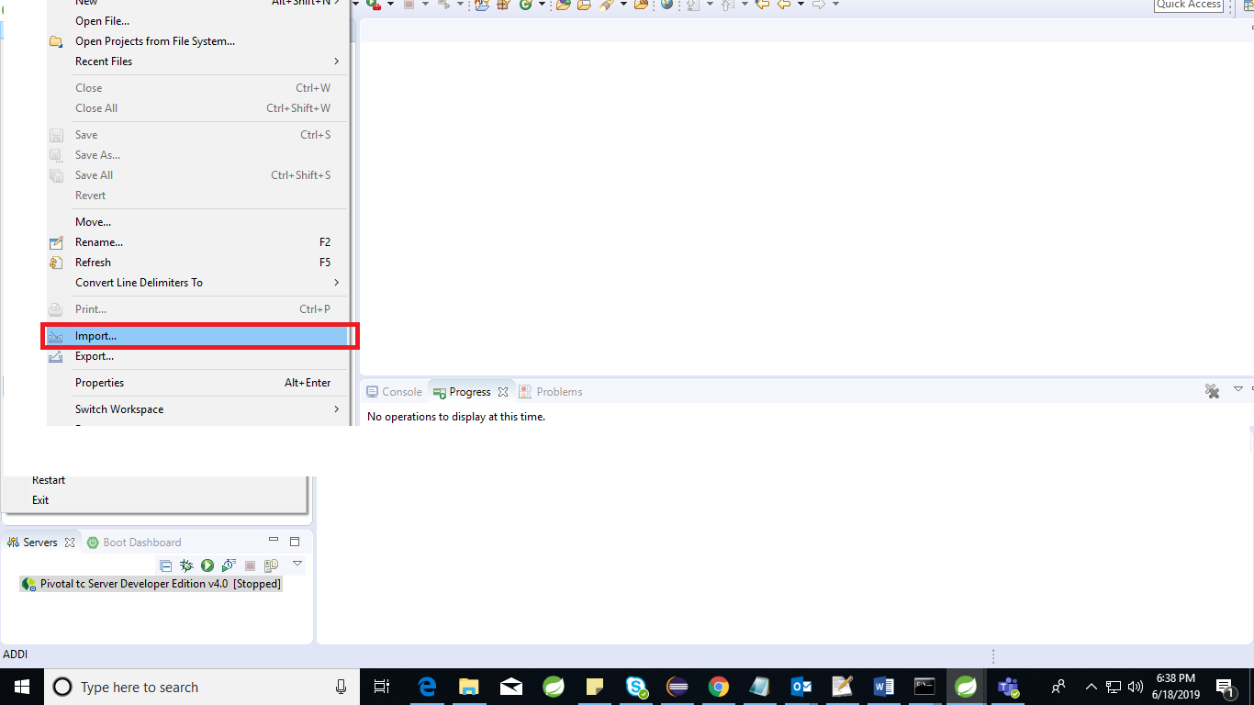

* Then click on ‘Maven’ and select ‘Existing Maven Project’

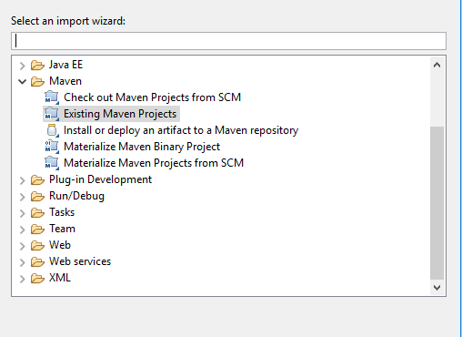

* Click on ‘Browse’ and go into the “ADDI-WS” directory and select the project

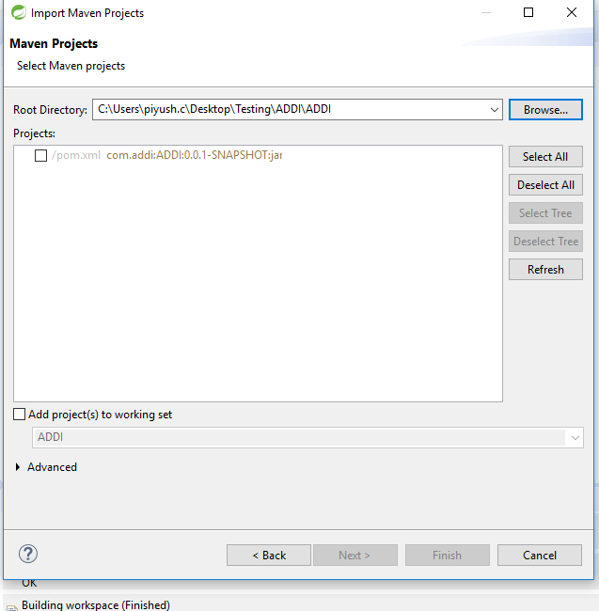

* After project selection clicks on ‘finish’

(Note: Internet is required because it will download the repositories)

1. Orient DB installation

* Download Orient DB latest version through the link [https://orientdb.org/download](https://apac01.safelinks.protection.outlook.com/?url=https%3A%2F%2Forientdb.org%2Fdownload&data=02%7C01%7Cpiyush.c%40hcl.com%7C0afe9f58bba74b3f501208d69e090585%7C189de737c93a4f5a8b686f4ca9941912%7C0%7C0%7C636870158913489770&sdata=ZImcSco4GvpegerSAk%2FMvS4%2BEixC%2BqmNMLjNHPonxvg%3D&reserved=0)

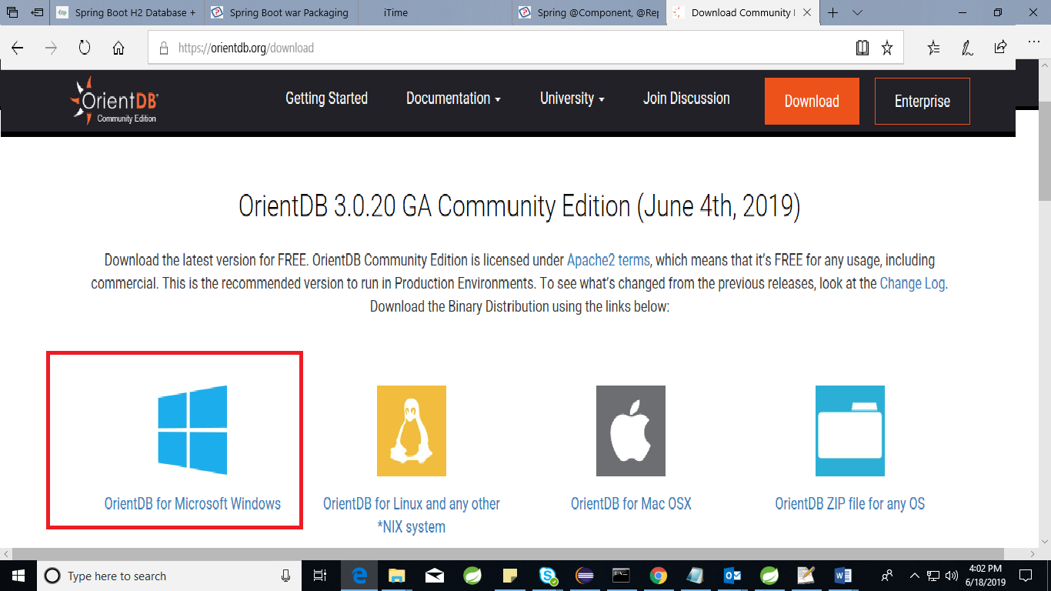

* Click on the “Orient DB for Microsoft Windows”. It will start download the zip.
* Extract the downloaded OrientDb and switch to bin directory.

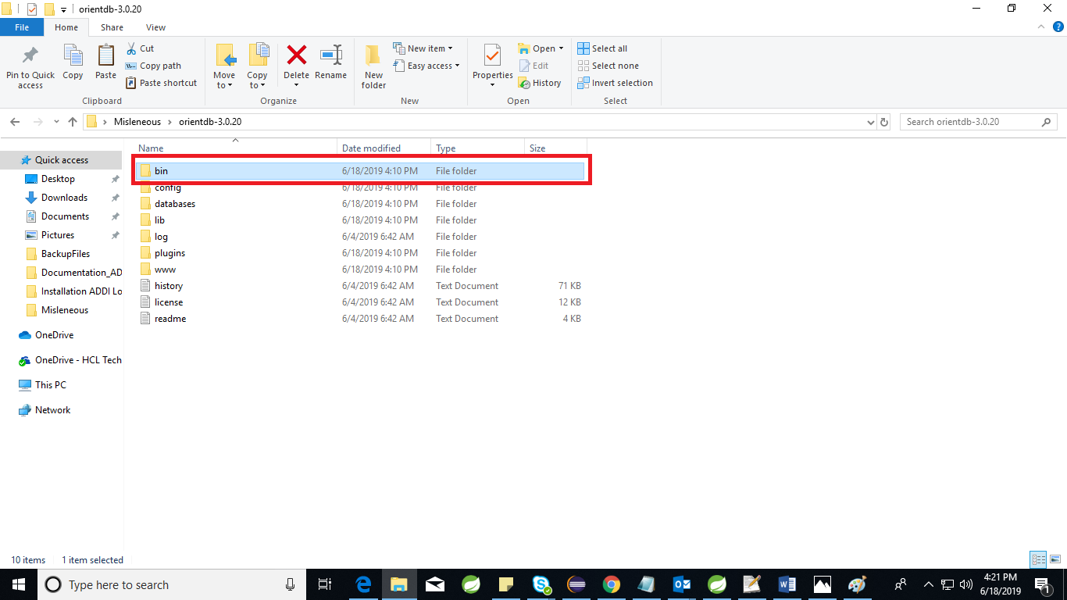

* Execute the “**server.bat**” file in command prompt.
* 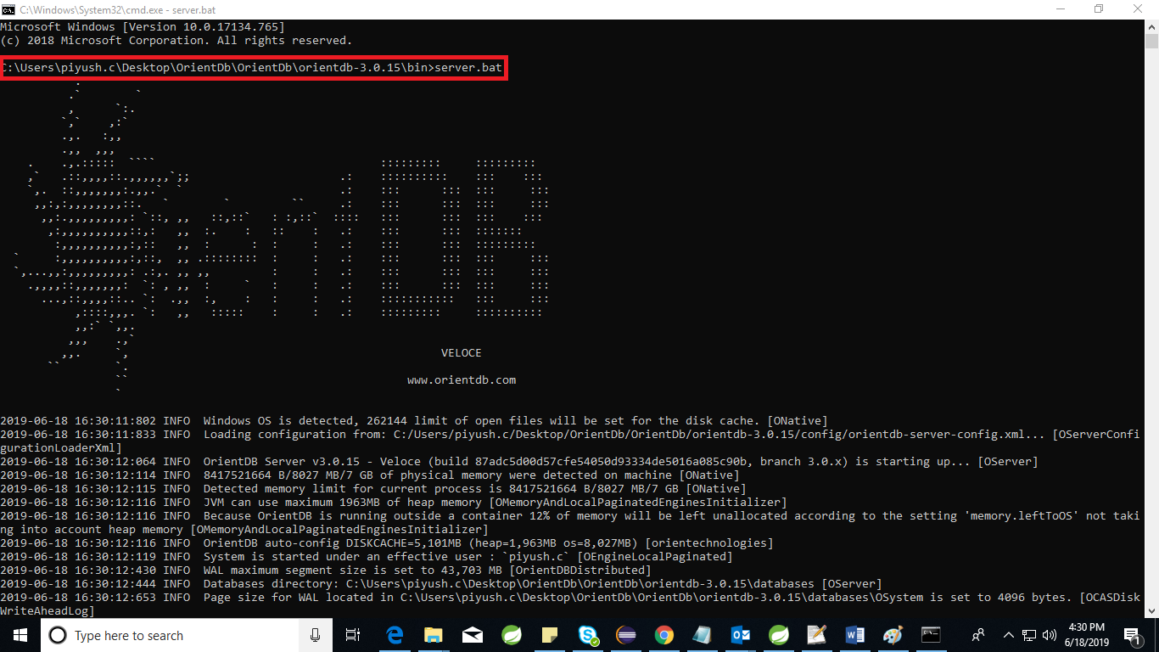
* Set orient DB password as “**admin**”

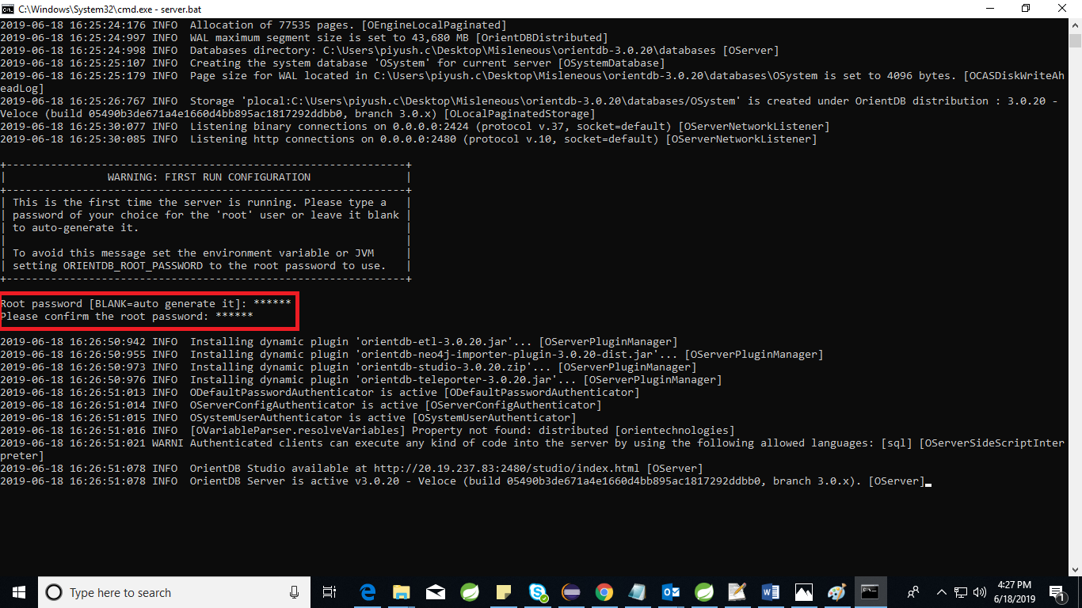

* <http://localhost:2480/studio/index.html#/> refer this link to open home page.
* Click on “**NEW DB**”
* Create new DB with name “**ADDIdb**” and set username “**root**” password “**admin**”

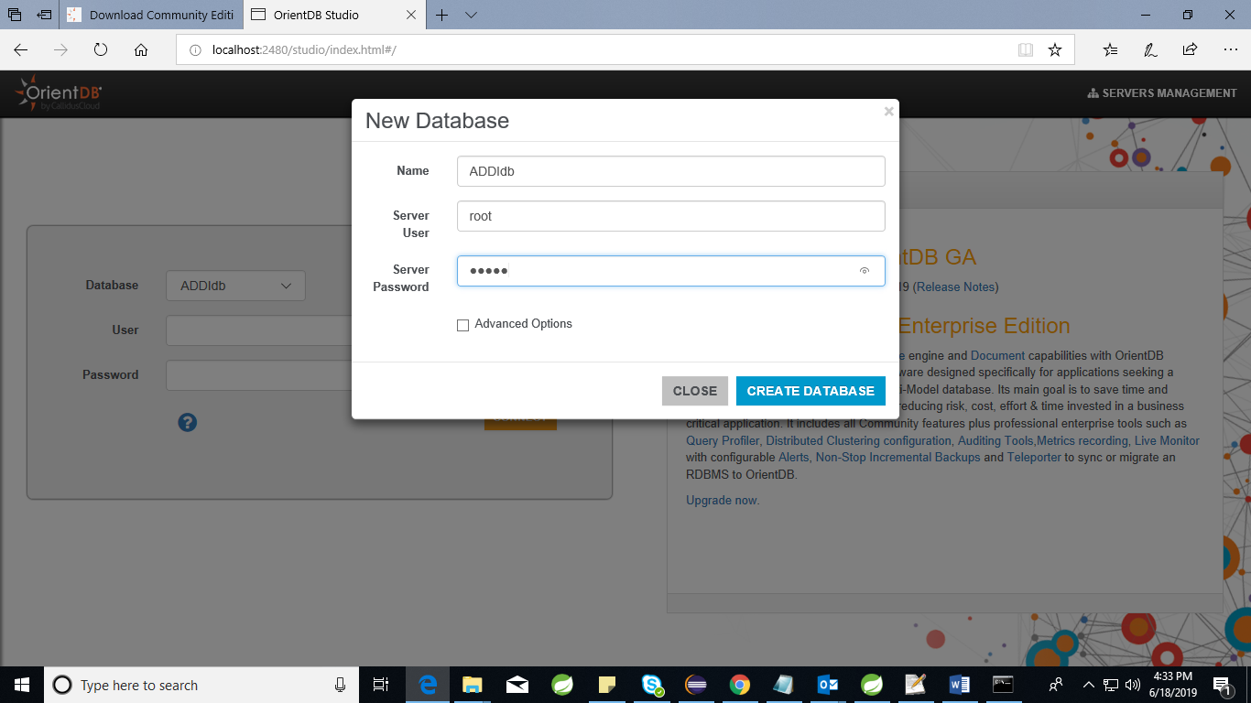

1. Execution of the ADDI application

* Create new folder with name ADDI inside local disk ‘C’ directory to keep “**ADDI-0.0.1-SNAPSHOT.jar**”.

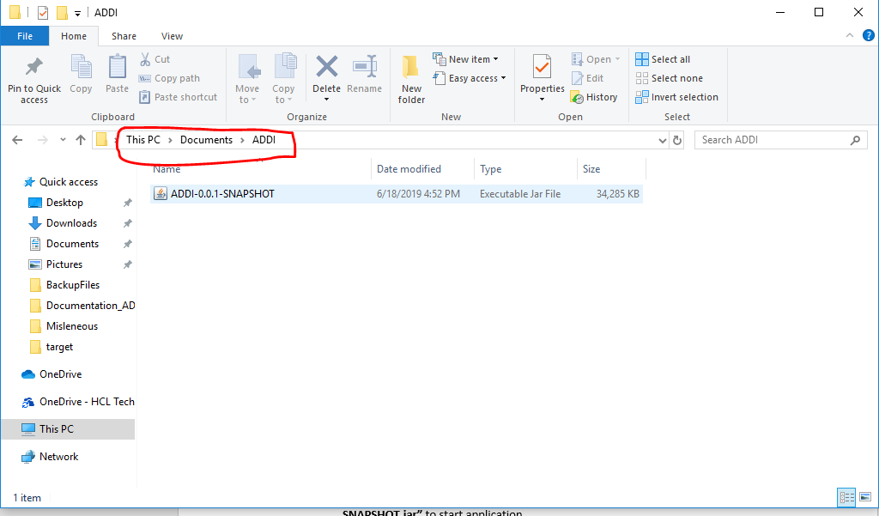

* Keep data files inside ‘C’ directory with any name.

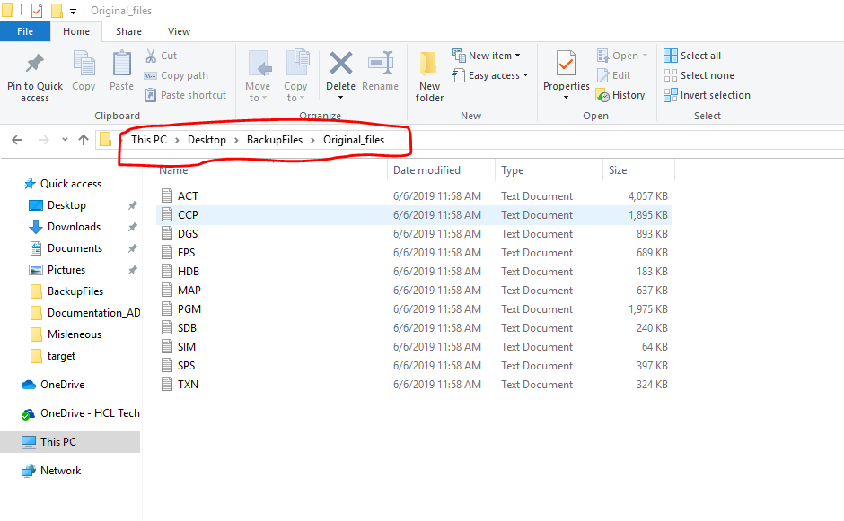

* Execute the command **“java -Ddatafiles=<path to datafiles> -jar ADDI-0.0.1-SNAPSHOT.jar”** to start application.
* Refer the below image to execute command



1. End Urls

* <http://localhost:9090/hogan-connector/batch/data/files> click on this url to save the datafiles into Orient database.

Note: *It takes approx. 40 to 50 min to save all the datafiles.

*Make sure “server.bat” should be running before executing above url.

* To execute functionality and services of ADDI please refer below link <http://localhost:9090/swagger-ui.html#/>